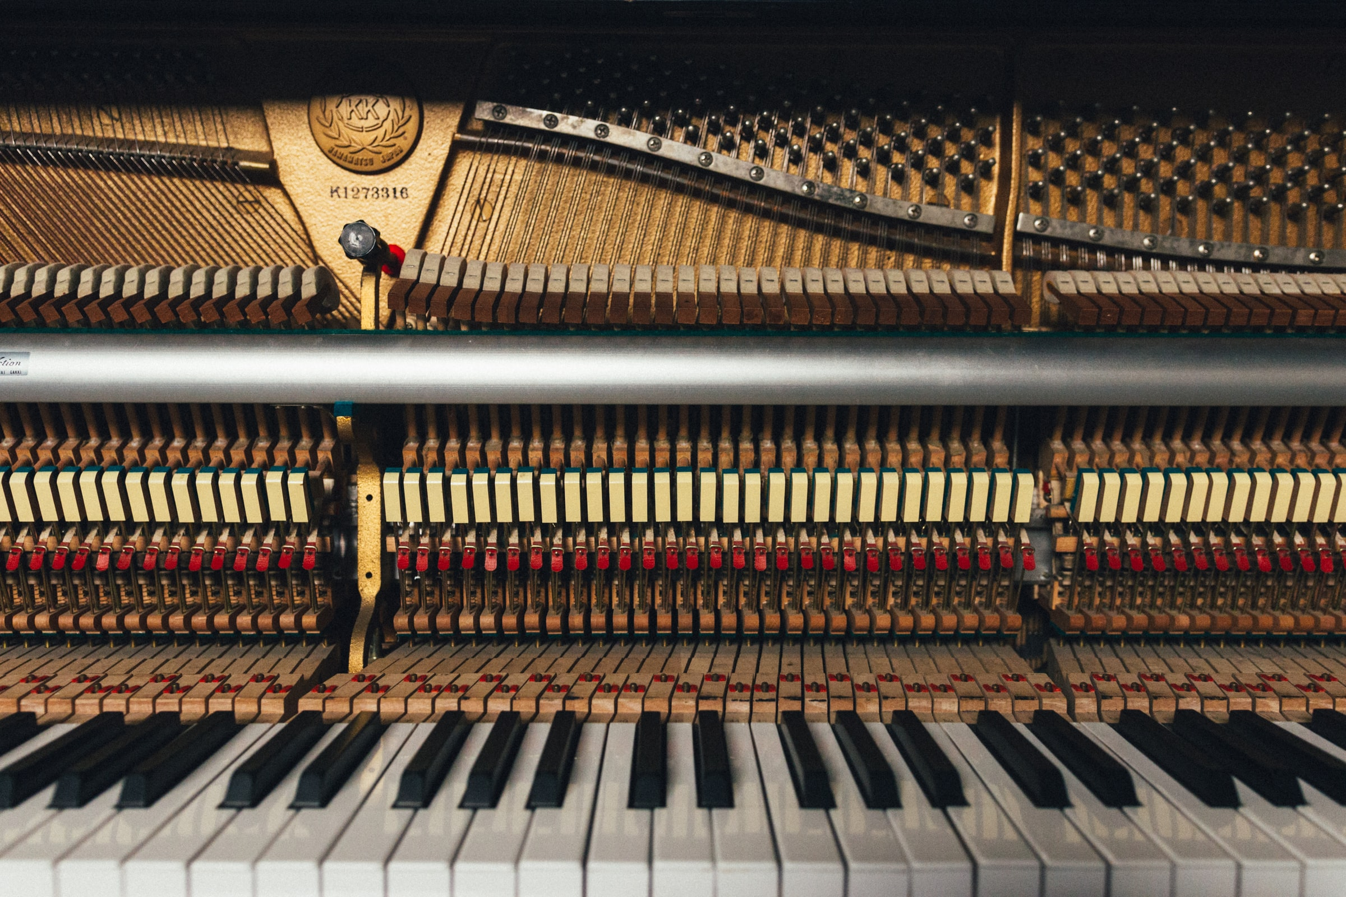

Student Handbook 2021

asdf

Your musical journey awaits…

Helping students achieve their musical dreams,
one note at a time.

We’re so excited that you have chosen to study with us! Choosing a music school can be a tough decision, as there are so many good places to choose from.

At Xavier’s School of Music, we demonstrate a more personal, tailored level of teaching, where all students are given the proper attention they need to achieve their musical dreams. We always make sure to teach our students what they want to learn, rather than forcing an existing curriculum upon them. Our detailed statement of teaching philosophy can be found on the next page.

Statement of Teaching Philosophy

“Music is the only language that doesn’t require translation.”

~ Nathanael Xavier, Founder

Music is the only language that doesn’t require translation. Everyone can speak a language, but the language of music comes as an inspiration from deep within an individual. Inspiration is the spark which creates the interest to learn and the desire to achieve one’s goal. While adapting to each student’s individual style, our goal is to establish a strong musical foundation in a fun, interactive and inspiring way.

​ Xavier’s School of Music accepts students from all walks of life, because we believe that it is never too late to journey into the world of music. Our private lessons revolve around the internationally-recognized RCM Syllabus, although students also have the option of learning material outside this curriculum.

​ Not all students learn the same way, and each student has his/her own unique learning abilities. When a new student starts music lessons, the teacher spends some time getting to know him/her, then makes an assessment of the individual’s strengths and struggles, and continues to develop the student’s capabilities while targeting the areas of concern on a regular basis. For example, a student who is having trouble keeping the wrists up and fingers curled, can be given several hand and finger strengthening exercises to enhance his/her playing technique in a fun and interactive way. Or a student who is having difficulty in ear training may be asked to listen to a favourite song many times (jazz, pop, classical, etc.) and then play back a short passage of the main melody with some help, thus greatly strengthening the ear technique while having fun.
​
Students will develop a strong foundation in the fundamentals of music including new repertoire, technical exercises, sight reading and ear tests, and a theoretical component in every lesson. With this acquired knowledge, the student can address his/her short and long term goals, including anything from wanting to play an instrument as a hobby, to possibly starting a career in music.
​
Being Toronto’s newest music school in the Scarborough/North York region, Xavier’s School of Music welcomes you into our community and we wish you all the success that music has to offer!
Student Checklist

“Music washes away from the soul the dust of everyday life.”
~ Berthold Auerbach

Please make sure to come prepared for each class! Below are some things to bring with you every week.
Your instrument (doesn’t apply to piano students!)
The class wouldn’t be much fun if you forget your instrument or a part of an instrument (for example, you bring your violin but forget the bow). Please make sure you have everything that is required to play your instrument before you come to class.
Writing utensils
Although your teacher will have something to write with, it’s always a good idea to carry a pencil, eraser, pen, and maybe even some coloured pencils (especially for younger students) because you never know when you might need them!
Notebook
At the end of a class, your teacher writes down everything that was covered for that class, along with your homework and some helpful practice tips and techniques. It is very important to bring your notebook to class each week so that your teacher can remember what was covered in the previous lesson and can move on to something new.
Music books and lesson materials
You may be required to purchase additional books depending on what your musical goals are. Students following the RCM curriculum must bring their Celebration Series books for their level (a mixture of technical tests, four star and sight reading exercises, theory, etudes and repertoire). If you are not in the RCM curriculum, your teacher may give you additional material to work on (sheet music, theory pages, take home tests, etc.). If you have any doubts on what to bring, please contact your teacher.

And last but not least,
An open mind ready to learn music and have fun!

Studio Policy

“Music produces a kind of pleasure which human nature cannot do without.”
~ Confucius

The following rules and regulations will be in effect from January 1st, 2021 henceforth:

- Payments

Monthly
Moving forward, the payment structure will be set to monthly via Etransfer. Please do not pay for multiple months in advance. More importantly, it is the parent’s responsibility (or the student’s responsibility if 18 or older) to make sure that the payments are on time. The teacher may not always have the opportunity to send out email reminders every month for every student, so please make sure that you set a reminder in your calendars each month to avoid suspension of lessons (see “Late Payments” below).

Late Payments
If you are unable to make a payment for whatever reason, please contact the teacher preferably before your next payment is due. Payments for each month must be received by the 7th of each month. If no payment has been made within this timeframe and no effort has been made to contact the teacher with a valid reason for delayed payment, lessons will be suspended.

- Class Cancellations

Canceling a lesson one or more days in advance
When it comes to cancellations, the sooner the teacher knows, the better. If the student/parent knows of a specific date or set of dates that they will be unavailable, please notify the teacher as soon as possible. If a class is cancelled at least one day in advance, one of the following will occur based on the availability of the student and teacher:

- The student will receive one credit for the class, and the teacher will make up the class any time during the same month. This will be done either by scheduling a separate day to have the makeup class, or by adding extra time to the remaining classes in the month. For example, if John misses a 30-minute class, his next class could be 1-hour long, or this can turn into two, 45-minute classes to make up for the 30 minutes that were lost.

“A painter paints pictures on canvas. But musicians paint their pictures on silence.”
~ Leopold Stokowski

OR

- If a makeup class is not possible (for example, there is no opportunity or availability to make up the lost time), the material intended to be covered during the class shall be sent to the student/parent. This lesson material can include any of the following: typed-out notes, sheet music, theory worksheets, and/or video tutorials. This is intended to provide the student with some practice material to ensure their ongoing progress despite not having a regular lesson.

Canceling on the day of your lesson
If a class is canceled on the day of the student's lesson without a valid reason, the material intended to be covered during the class shall be sent to the student/parent. This lesson material can include any of the following: typed-out notes, sheet music, theory worksheets, and/or video tutorials. This is intended to provide the student with some practice material to ensure their ongoing progress despite not having a regular lesson. A credit will NOT be given to the student for a class canceled on the same day of the lesson without a valid reason* (see “Valid Reasons” below).

*Valid Reasons: Sickness or extenuating circumstances
Since lessons are entirely online now, having a music class is more accessible and requires less effort and resources than having to commute to the teacher’s home. In light of this, students are strongly encouraged to attend their lessons even if they are feeling unwell, provided that they can concentrate and play their instrument to the best of their abilities. For example, if a student has a cold, cough, or other mild symptoms, the student is still encouraged to show up to their lesson. If you would like a credit for missing a lesson due to sickness, then a doctor’s note will be required. Once the teacher can confirm the reception of a valid doctor's note, the lesson will be canceled and the student will receive one credit for the class (to be made up during the same month if possible). If no doctor’s note is provided, the student/parent will receive lesson material via email in lieu of the regular lesson.
Extenuating circumstances are situations in which the student has no control over. Technical difficulties with an internet connection, video/audio issues, excessive lag during the lesson, etc. can also fall under this category. In the event of an extenuating circumstance, a detailed explanation must be given to the teacher outlining the reason why the student is unable to attend the lesson. In these situations, the student will receive one credit for the class (to be made up during the same month if possible).

“The true beauty of music is that it connects people. It carries a message, and we, the musicians, are the messengers.”
~ Roy Ayers

If the teacher cancels a lesson
Regardless of the reason, if the teacher cancels a lesson, the student will always receive a credit. The teacher will try to make up the lesson during the same month, and if this is not possible, the lesson will be carried over to the next month.

- Lateness and Homework

Lateness
Lateness for any reason will not be allowed. Please make sure your devices have been sufficiently charged so that they do not die in the middle of the lesson, and please give yourself adequate time to set up the lesson space. The teacher will not make up time lost if a student is late. If there is a technical issue or extenuating circumstance, it is the student's responsibility (or the parent's responsibility if the student is under the age of 18) to contact the teacher immediately to explain the situation. Regardless of the reason, the teacher cannot guarantee that any lost time will be made up.

Homework
It is expected that students complete the homework assigned to them each week. If this is theory homework, the student must have it completed before their next class, no excuses (unless the student was severely ill). Students who fail to complete their homework will be given up to 3 write ups. If the student accumulates more than 3 write ups, the parents will be contacted and the teacher reserves the right to cancel the lesson, in which case no credit will be given.
In short, try not to miss your lessons, don't be late for your lesson, and complete your homework on time!

“Where words fail, music speaks.”
~ Hans Christian Anderson

- Other Important Updates

Dress Code
Students should come to their lessons dressed as if they were in a school. Please avoid wearing PJs to your lesson! If the student is found to be underdressed or wearing inappropriate attire, they will be asked to change into something more suitable. Unfortunately, this time cannot be made up.

Cell Phones
During a lesson, cell phones should be kept on silent mode so as not to pose a distraction. Under NO circumstances will audio or video recording of the lesson be permitted, on any device.

Drop off and Pickup (in-person lessons)
In the event that in-person lessons resume, parents are NOT allowed to wait inside the class with the student, regardless of the student’s age. Parents can drop off students for each lesson, and pick them up when the lesson is finished.

Lesson Rates for Current Students
Instead of raising lesson prices this year, it has been decided to keep prices for all current students the same, provided that this new studio policy is adhered to. Also, please take into account that all lessons will remain online until further notice, and this new policy applies to both online and in-person lessons (in the event that in-person lessons resume).

Lesson Rates for New Students
The following prices will be in effect for new students who enroll in lessons from January 1st, 2021 henceforth:
 | 30 minutes | 45 minutes | 1 hour
Beginner* | $25.00 | $37.50 | $50.00
Intermediate* | $30.00 | $45.00 | $60.00
Advanced* | $35.00 | $52.50 | $70.00
*Please note that the teacher will decide whether the student is at a beginner, intermediate, or advanced level after the student has completed their free assessment.

“Music is the art of the prophets and a gift from God.”
~ Martin Luther
Referral Program
Parents and students are encouraged to refer their friends and family to enroll in music classes at Xavier's School of Music. The referring parent/student shall be awarded one free lesson, provided that the new student first signs up for at least one month of lessons (4 classes minimum).

Guidelines for Online Lessons
Since students will be taking lessons in the comfort of their homes, we ask that the following measures are taken into account to minimize distractions:
- Keep the lesson space clean, tidy, and well-lit
- There should be as little background noise as possible.
- A device with a large screen, webcam/front facing camera, and microphone (either built-in or external) is recommended, such as a PC, laptop, or regular-sized iPad. If none of these are available, Android or iOS phones can be used. Please make sure devices are fully charged, as online video conferencing can use up a lot of battery.
- If possible, have a backup device such as a phone, tablet, or laptop to use if your primary device fails during the lesson.
- Make sure you have a steady internet connection to minimize video/audio lag and other technical issues. It is recommended to stay close to your internet router during the lesson, if possible.
- Show up on time; make sure you give yourself enough time to set up the space prior to the lesson.
- You should know how to take a screenshot on your device, as your teacher will be giving you notes over the screen. Taking a screenshot of the notes will help you remember what you need to practice until the next class.
- Although not mandatory, it is recommended to use headphones during your lesson for better audio quality.

“Music expresses feeling and thought without language; it was below and before speech, and it is above and beyond all words.”
~ Robert G. Ingersoll

Signature
Please sign below stating that you accept the terms and conditions as outlined in the Studio Policy section on pages 5 to 10 of the student handbook. Failure to abide by these rules will result in termination of classes, and no refund shall be given.

First and Last Name (please print)

________________________________________________

Signature of Parent/Student (age 18 or above)

________________________________________________

Date Signed

________________________________________________

Questions?
We’re here to help! If you have questions at any time, feel free to get in touch with us:
Email: info@xavierschoolofmusic.com
Phone: 647-389-3892
Address: #37, 30 Chichester Place, Scarborough ON M1T3S5
Website: www.xavierschoolofmusic.com
Facebook: www.facebook.com/XaviersMusicSchool/

